**Performance Test Report**

**For**

**Execution of**

**Masterdata templates – 200 users**

Date: 04 June 2020

Author: Gaurav Sharan

**Summary**

This report presents the observations and findings of the load test conducted for a load of 200 users on masterdata templates API.

The objective of this load test was to observe and record behavior of the application when user load is increased from 50 to 200.

Below are the scenario details:

|  |  |
| --- | --- |
| **Script/Report Name** | Masterdata template API |
| **Run Date** | 04-June-2020 |
| **Period** | 11:04:31 UTC to 12:23:59 UTC |
| **Number of concurrent users** | 50 to 200 |
| **Ramp up** | 01 user per second |
| **Run Duration** | --- |
| **Ramp down** | NA |

The transaction response times observed were as below:

|  |  |  |  |  |  |  |  |
| --- | --- | --- | --- | --- | --- | --- | --- |
| **Label** | **# Samples** | **Average(ms)** | **90% Line(ms)** | **Min(ms)** | **Max(ms)** | **Error %** | **Throughput** |
| TR_masterdata_ template | 429635 | 43 | 53 | 20 | 2658 | 0.00% | 90.1 |

**Performance Test Execution Details**

We have executed JMeter script for masterdata templates service, which has transactions mentioned in the above table.

Average response time of the APIs is 43 ms with error rate 0 %.

**Response Time and TPS Graph:**

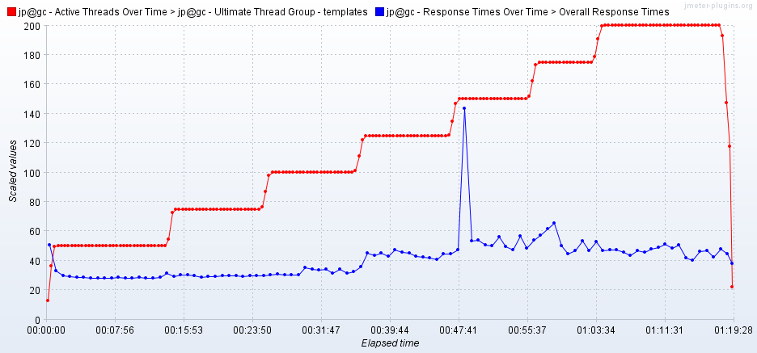

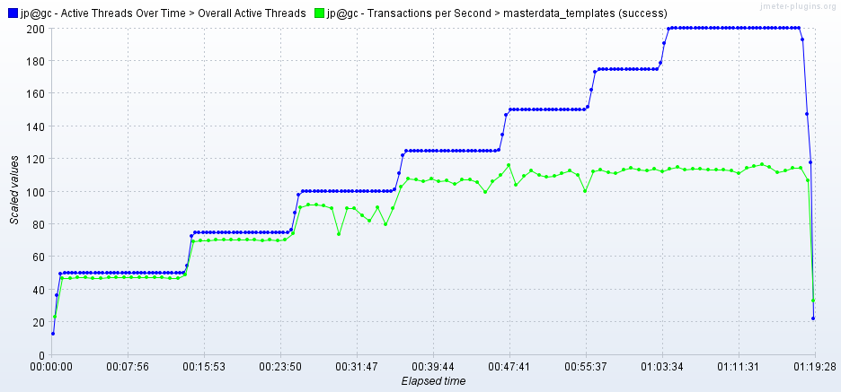

As seen in the graph, response time of the APIs is approx 50 ms when 200 users are active.

Throughput (TPS) of the APIs reaches 112 when 125 users are active and stays at same level irrespective of increasing number of users.